January 3, 2023

New Mexico Statewide Price Agreement (SWPA) Contractors and U.S. General Services Administration (GSA) Schedule Contractors
Santa Fe, New Mexico 87507

Subject: Request for Quote (RFQ) – Project Management Office (PMO) for Child Support Enforcement System Replacement (CSESR) project

The New Mexico (NM) Human Services Department (HSD) is procuring PMO services related to its current Child Support Enforcement System Replacement (CSESR) project, a project within the Health and Human Services 2020 (HHS2020) initiative. HSD is requesting quotes from contractors who hold a current NM SWPA or GSA Schedule for the provision of Information Technology (IT) Professional Services, Project Management Services or other applicable price agreement categories.
The instructions and information below are intended to assist the contractors in pricing a quote for HSD evaluation.

1.0 Distribution of this Request for Quote
In order to accomplish the HSD purpose of this initiative, this RFQ is distributed to contractors who currently hold an agreement under NM SWPA or GSA. The SWPA procurement category used for distribution is:
- Project Management Services

2.0 Purpose of this Request for Quote
The purpose of this RFQ is to obtain quotes from qualified contractors to provide fixed price work products to complete the implementation of a project management office to oversee the planning, procurement, development and implementation of the replacement/modernization of HSD’s Child Support Enforcement System (CSES). The deliverables will help meet HSD’s need for a CSES with extensions to other state, federal, and private systems to deliver integrated health and human services to enterprise customers. The deliverables are pre-defined to build upon critical investments in the current HHS2020 infrastructure, operating systems, databases, and applications generally comprising an enterprise integration platform.

Introduction, Intent and Objectives of this Engagement
HSD intends, through this RFQ and an associated contract, to partner with an industry leader in project management office services. This partnership is critical to the successful replacement of CSES. This project also includes integration to new and legacy applications that must interoperate with new emerging systems and shared services. These systems include:
- Medicaid Management Information System (MMIS) and associated modules, including:
  - System Integration Platform
  - Data Services Platform
  - Unified Public Interface
  - Electronic Content Management
  - Other shared services
- Automated System Program and Eligibility Network (ASPEN)
- Odyssey New Mexico Courts file and serve system
- Federal systems

Scope of Project Management Office services requested
The Statement of Work (SOW) outlines 4 distinct deliverables that involve managing the project from the Planning phase through the end of the Implementation phase.
Deliverable 1: CSESR Project Plans and Ongoing Project Management
Deliverable 2: Streamlined Feasibility Study HSD & OCSE versions
Deliverable 3: CSESR Implementation Advanced Planning Document (IAPD)
Deliverable 4: Request for Proposal (RFP) for soliciting a Contractor for Design, Development and Implementation of CSES Replacement, Quality Assurance Services, and Training Services.

Contractors are required to present their qualifications in each of these areas or the qualifications of a subcontractor that meets the specific requirements. Corresponding work products for each area are detailed in the accompanying SOW.

Request for Quote Overview
This RFQ is comprised of three (3) documents and supported by an on-line library of previously released public reference information. The three documents described below are specific to helping contractors respond to this RFQ. The online library contains reference material for this and several related procurements. The vendors are encouraged to review this library in preparation for responding to this RFQ.

- Invitation to Quote – this document.
- Instructions for Responding to this RFQ – Contains the RFQ schedule, format for responses, specifications for responses, evaluation process overview, contractor qualifications and other instructions.
- Draft Contract – Draft of the contract and Statement of Work used as a base for this contract.

Request for Quote Guidelines
This request for quote is issued under the following guidelines:
    - This notice is being distributed to Contractors holding current New Mexico SWPA agreements within the Project Management Services category. This notice may also be distributed to select Contractors with current GSA Schedule related to Project Management Services.
    - The HSD will review quotes and intends to award one contract to manage the CSESR project.
    - The HSD expects the awarded contractor will use internal staff or subcontractors to meet contract requirements. Regardless, the HSD will require the contractors to maintain or coordinate staffing to cover turnover to prevent interruption of services.
    - Work is conducted at State offices in Santa Fe or remote. Contractor’s staff and subcontractors must agree to HSD security standards related to building, network, or system access. Working from remote or other non-State office must be approved in advance.
    - The HSD may amend the contract for other related services in the future based on strategic needs of the project.
    - A draft state approved contract is included. The terms and conditions are consistent with state procurement codes and include several terms related to federal funding requirements.
    - Any contract awarded will be reviewed by the Department of Finance and Administration, the Department of Information Technology and the Office of Child Support Enforcement (OCSE). Their review may result in requests for changes to the terms and conditions or statement of work. The HSD will review requested changes with the Contactor prior to acceptance.
    - Upon review of the quotes, the HSD will contact initial qualifying contractors. Only one quote will result in a contract.
    - The selected contractor will be considered the prime contractor with any major subcontractors identified by name. All subcontractors must comply with the HSD security, privacy, policies, and codes of conduct. Required online HSD training will be provided at no charge and must be completed annually per federal or state regulations.
    - The pricing must be firm for 180 calendar days after the due date for receipt of quotes.
    - Per state transparency laws, quotes will be considered public record.
    - This Request for Quote may be canceled at any time and any and all quotes may be rejected in whole or in part if in the best interest of the HSD.
    - Any contract awarded as a result of this RFQ process may be terminated or adjusted if sufficient appropriations or authorizations do not exist or are reduced.
    - The HSD may accept all or a portion of the quote.
    - All submitted documents shall become the property of the HSD.

Contract Considerations
The quotes will be reviewed based on HSD determination and need; the HSD intends to award one (1) contract. The following should be considered:
    - The attached contract is a standard HSD IT contract. Contract articles will not be amended unless specified in a Legal Evaluation of Statement of Work (see Instructions). Please review the contract before submitting quotes to confirm the terms are acceptable.
    - Although retainage is set to 20%, the HSD may adjust retainage based on risk or experience levels of quote presented.
    - The contract states “fixed price deliverables” as the basis for reimbursement.
    - A warranty of six (6) months for work performed or deliverables submitted is included. This will address possible situations in which faulty work is not discovered at submission. Work found faulty after submission will be corrected at no charge to the HSD.
    - HSD may extend contract terms beyond four years per HSD procurement options for Child Support Enforcement Systems. The term of the contract will not extend beyond the statute limit.

HSD Procurement Strategy
This procurement will be conducted in a manner providing full and open competition consistent with New Mexico State procurement requirements. In order to ensure objective contractor performance and eliminate unfair competitive advantage, contractors that develop or draft specifications, requirements, statements of work, or invitations for bids or requests for proposals must be excluded from competing for such procurements. Some of the situations considered to be restrictive of competition include but are not limited to:
(1) Placing unreasonable requirements on firms in order for them to qualify to do business;
(2) Requiring unnecessary experience and excessive bonding;
(3) Noncompetitive pricing practices between firms or between affiliated companies;
(4) Noncompetitive contracts to consultants that are on retainer contracts;
(5) Organizational conflicts of interest;
(6) Specifying only a “brand name” product instead of allowing “an equal” product to be offered and describing the performance or other relevant requirements of the procurement; and
(7) Any arbitrary action in the procurement process.

Human Services Department Responsibilities

Appendix 8.2 and 8.3 includes a Project Organizational Chart and HSD roles and responsibilities. The Project Team will include personnel from Child Support Enforcement Division (CSED) and Information Technology Division (ITD). These teams will report up to the Project Director who will be involved with the project on a daily basis. The HSD Executive team will steer and sponsor the project on a weekly basis.

Appendices

8.1 Appendix A: List of Acronyms
A list of acronyms is provided below:
Acronym | Definition
ACF | The Administration for Children and Families
ASPEN | Automated System Program and Eligibility Network
CSESR | Child Support Enforcement System Replacement
DS | Data Services Platform
ECM | Electronic Content Management
GSA | U.S. General Services Administration
HHS | Health and Human Services
HHS 2020 | Health and Human Services 2020 Initiative
HSD | Human Services Department
IAPD | Implementation Advance Planning Document
IT | Information Technology
LD | Liquidated Damages
MMIS | Medicaid Management Information System
Multi-Ops APD | Multiple Operations Advance Planning Document
NM | New Mexico
NMGRT | New Mexico Gross Receipts Tax
NoSQL | Not Only Structured Query Language
OCSE | Office of Child Support Enforcement
OIG | Office of Inspector General
PAPD | Planning Advance Planning Document
PMO | Project Management Office
RFP | Request for proposal
RFQ | Request for Quote
SI | System Integration Platform
SLA | Service Level Agreements
SWPA | New Mexico State-Wide Pricing Agreement
UPI | Unified Public Interface

8.2 Appendix B: HSD Project Organizational Chart
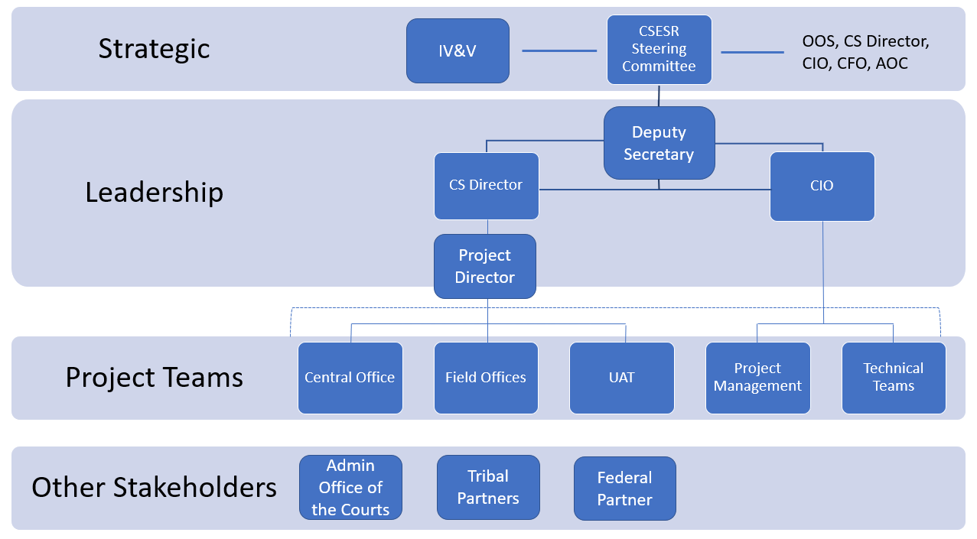
8.3 Appendix C: HSD Roles and Responsibilities
Executive Steering Committee (Voting Members)
Title / Role | Responsibilities
Deputy Secretary | Authorizing changes to Scope, Schedule and Budget
Acting Chief Information Officer | Authorizing changes to Scope, Schedule and Budget
Acting IV-D Director | Authorizing changes to Scope, Schedule and Budget
Project Director | Executive Oversight of Project
Project Team
Title / Role | Responsibilities
IT Project Manager | Project Management and oversight of contractor. Review and approve deliverables.
ITD System Admin Bureau Chief | HSD system administration and network services. Review and approve deliverables.
CSES Technical Lead | CSES Subject Matter Expert (SME). Review and approve deliverables.
CSED Programs Bureau Chief | CSED SME. Review and approve deliverables.
CSED Business Project Lead | CSED SME. Review and approve deliverables.
Contract Manager | Contract Manager. Fulfill all contract manager functions.

Sincerely,

Paula Morgan
Acting Chief Information Officer
New Mexico Human Services Department
Attachments – RFQ CSESR PMO

